Development Log

Academic week #7 (17th to 23rd Nov)
During the practical Friday lesson, I researched more about tests and how to organize them as it will be when having hundreds of tests for one program. This is because each Junit testing of a methods needs multiple tests so one method per test method is too compact and one separate class file per test is too wide to be practical.
Did eventually come across test categories Java annotations but the only valid ones are class names which defeat the point of them. Source - https://junit.org/junit4/javadoc/4.12/org/junit/experimental/categories/Categories.html
Did also come across another JUnit Java annotation which were much more useful for organizing huge amounts of tests:
- Tag annotation for distinguishing types of tests - https://www.baeldung.com/junit-filtering-tests
- Nested class annotation - https://www.baeldung.com/junit-5-nested-test-classes
Due to major indigestion and nausea problems, I couldn’t do anything else.

Academic week #8 (24th to 30th Nov)
Due to my 5-month stomach I had to talk to student engagement for an additional extension to the first COMP7007 assignment.
Was a bit confused when mark scheme said 10% was for this log doc; I thought David said it didn’t count towards marks. Should prob ask him abt that at some point.
Started this development log.

Project requirements
Copying from my lecture notes, this assignment should be mainly abt:
- Web APIs
- JUnit
- Records
- Lambdas (including streams)
Assignment confirms this but with additional things:
- Development log
- Retrieval and decoding of data
- Interactive functionality
- README file describing how to use the interactive front end
I Believe “Retrieval and decoding of data” means using JSONs well, but unsure what “Interactive functionality” means. Is simple CLI not enough? Does it need to be advanced enough to require a README UI manual file?
“Note that you are not required a complete set of JUnit tests. You just need to demonstrate that you can write effective JUnit tests. Ten tests would be sufficient, for instance. You are not required to write tests that fail (that is, ones that evidence errors in the program).” oh thank you David! :D
“text-based interactive” What console requires a manual? What if I print the manual in the console instead?

Project plan – list
Okay, so far, this what I think the program should do:
- Print what the programs do and how to interface with it.
- Ask and take in for which the program wants to fetch weather data from; those being:
- specify date ranges
- magnitudes of interest
- locations of interest for the data to be retrieved
- Fetch the data (from https://earthquake.usgs.gov/fdsnws/event/1/query?format[...]) but ensure it returns JSON, not XML – make program expect JSONs only as per assignment specification.
- To demonstrate use of Records, format the wanted JSON data into a Record. Use nested records if data structure is a bit too complex… actually doing nested records will show a greater understanding of Records.
- Do local processing, even if API may provide it already, ensure some local processing happens to get marks.
- Print the results of the processing such as area of most affected, averages, comparisons, etc. “possibly multiple times” indicates that the more the better.
- Make sure user knows what user can run diagnostic tests (JUnit testing) to ensure program works fine.
- Ask user if user wants to query (start from step #2) again to allow multiple queries to be made.
Lambdas and Streams must be used in step #4 and #5.
Records are quite simplistic in nature, so I will have to use it fully but without violating Single Purpose, Loose Coupling, or whatever it is called.
Because most likely things will not go according to plan, divide and conquering with single purpose classes is best as it allows great adaptability. Such is how the program will be planned. The plan:
- Class for taking in preferences, fetching JSON, and formatting wanted data into a Record using Lambdas and Streams. Also include validation of presences and use extensive error-prevention code when interacting with the web API. Class should be singleton pattern as it is generalist and only one is needed for the whole program (unless concurrency which I will not use).
- Class for using Lambdas and Streams to locally process the query-response Records. Again, singleton class.
- Class with Static main to start the program. Ig one would call this a command pattern class.
- Interpreter and composite pattern class to handle CLI and interface it to the other classes.
- JUnit testing class for testing the fetching JSON class as a lot of things will go wrong with that – both mistakes and external errors. Each method tested will have a dedicated nested class, and each method of those nested classes will test a specific aspect of the tested method.
This plan assumes that it is a good idea to include concepts from the first half of COMP7007 too.
This plan is just the baseline draft, polishing and additional functionality may be added depending on how early I finish the product – so how my stomach fares.
In respect to the plan I think the classes should be named (respectively):
- RecordFetcher
- RecordProcessor
- TestingRecordFetcher
- EarthquakeInterpreter
- Main
Names are convenient to me but may change them, near the end, to fit the assignment’s views of good OOP.

Project plan – UML
Based on these descriptions I will make a UML but a very quick and simple one as I don’t think UML counts as marks here.
I don’t think this program is complex enough to make use of inheritance, abstract classes, interfaces, etc. Hope this does not deduct marks.
Searching for a UML diagram maker that can generate skeleton (empty) Java classes and methods from it. Found this - https://www.jetbrains.com/guide/java/tips/generate-uml-diagram/ .
IDEA IDE’s built-in UML plugin works but the creational tools always freeze the IDE so I must make the skeleton classes themselves first then reflect them in the UML.
Spent the remainder 3 days finishing the A1 work then proceeded to have a 2-day straight severe headache.

Academic week #9 (30th Nov to 6th Dec)
When making the skeleton classes I made some new additions:
- ‘ClientActions’ interface to simplify dictation of what user can and cannot do – easily keep track of.
- The query report record will have a nested record of the API retrieved data while the report record will contain the local processing in its constructor.
- An enumeration for all query params – easily keeps track of.
- Query args validation will be delegated to a leaf class – to prevent ‘RecordRetriever’ class with so many methods that it looks like a “god class”.
- The sheer amount of query args makes it more suitable to pass them as a EnumMap than individually.

Analyzing JSON structure
Used the sample query “ https://earthquake.usgs.gov/fdsnws/event/1/query?format=geojson&starttime=2014-01-01&endtime=2014-01-02 ” to see json structure.
uppermost structure:
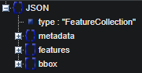
“metadata” can be good to confirm API version and the HTTP status code values, but “features” is the main thing we want.
Each Earthquake entry is in Features labelled as indexes:
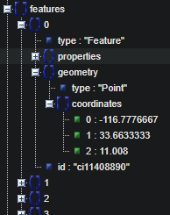
Not sure what they mean by “feature”.
Geometry object is simply about location, and its data structure is nicely small.
Properties on the other hand consists on more content and having confusion abbreviations:
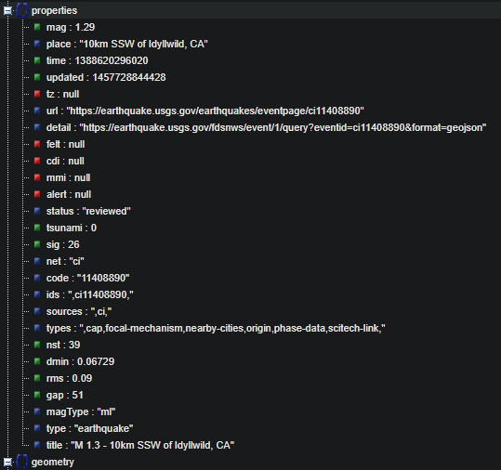
Going to put URL of what the program would send (based on what I put in ‘QueryParam’ enum and example values):
https://earthquake.usgs.gov/fdsnws/event/1/query?format=geojson&jsonerror&limit=5&latitude=0&longitude=0&maxradiuskm=10000&starttime=2025-09-30&endtime=2025-10-29&minmagnitude=0&maxmagnitude=9
API request surprisingly worked first time:
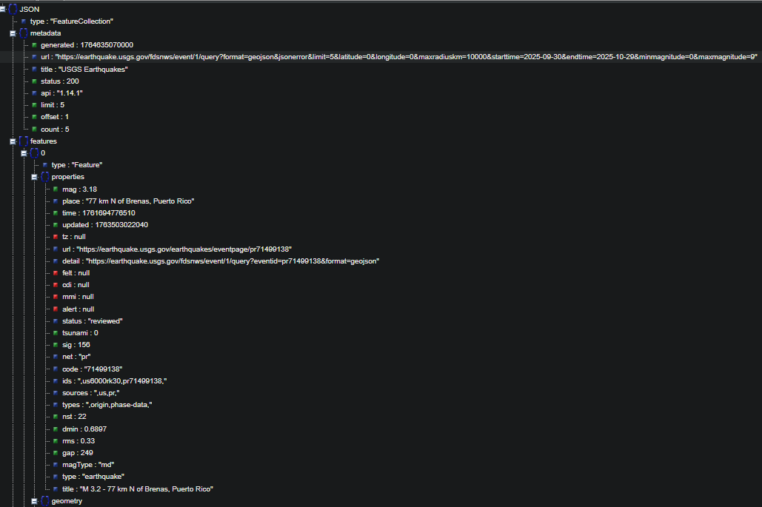
Features has numbers 0-4 so they are indeed indexes.
Structure of “properties” appears near or is identical. Referred to “ https://earthquake.usgs.gov/data/comcat/index.php ” for info about the abbreviations, and these have varying levels of relevance from exactly what we want to wondering why they are there in the first place.
Here is a list of what we want in every “features” entries:
- “mag” – magnitude’s magnitude
- “magType” – scale of magnitude used. In the JSON, seems different scales are used for different entries for some reason.
- “place” – human readable information – will be displayed in raw data but not processed on for obvious reasons.
- “time” – original time of earthquake (not to be confused with “updated”)
- “coordinates” – structured as [longitude, latitude, depth]
Other useful entries:
- “api” – check version to warn user of any unexpected behaviour if API underwent a major update recently.
- “status” – check if the API query was successful (code 200) or not.
From this more additions was made to the skeleton classes project:
- Enumeration for the wanted “features” entries
- Said enumeration will be used in an enumeration dictionary array list to store each earthquake instance.
- Earthquake data records will contain the enumeration dictionary array list alongside the methods that fetches data sets from it, such as:
  - Returning array of LocalTimeDate instances of every earthquake entry
  - Returning array of magnitudes (as doubles) but not before converting them all into being of the same earthquake magnitude scale.
- Earthquake type should also be its own enums… so many enums
To simplify the Earthquake status enum record I will:
- Split up ‘COORDINATES’ to longitude, latitude, and depth so I use 3 doubles instead of another enum dict
- Convert magnitude scale in every entry into a common one so I do not need to store the magnitude type.
Now I don’t think a enum for magnitude types is needed as I only find enums worthwhile if both the enum constant names and their string representations are exclusively used.
Looked at https://www.usgs.gov/programs/earthquake-hazards/magnitude-types
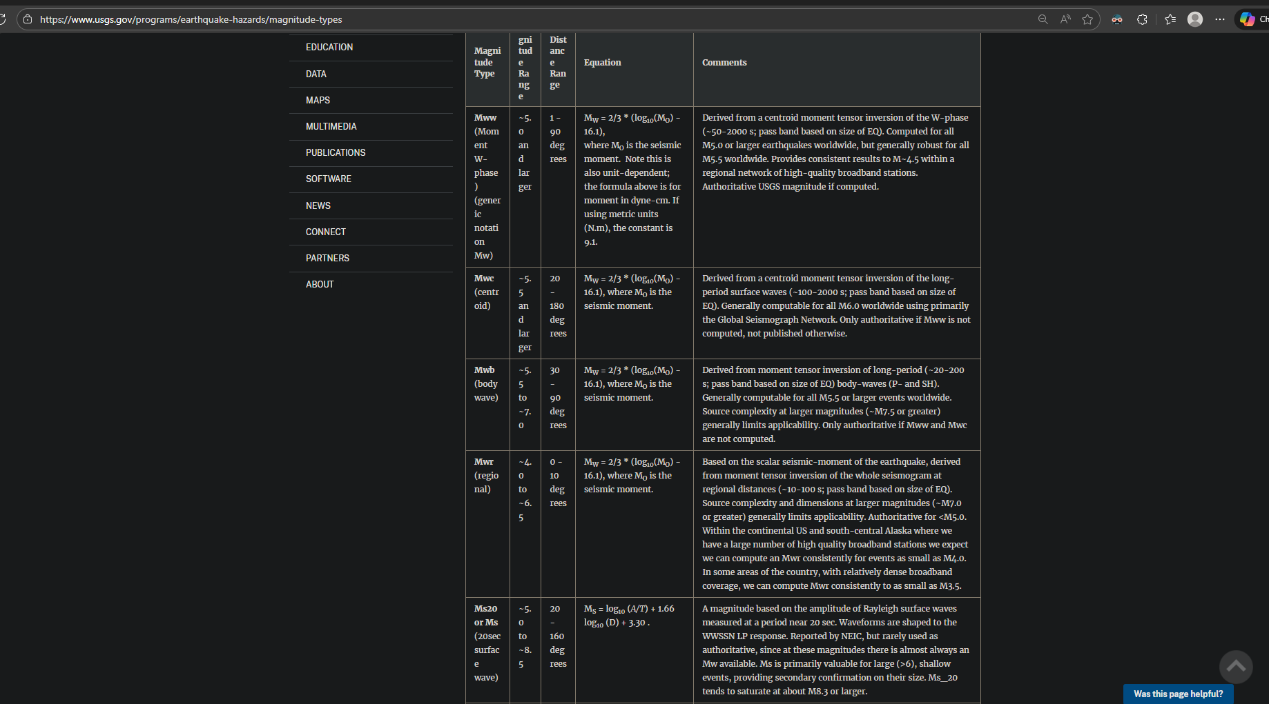
^ barely understandable table format
Seems like the scales used are: mww, mwc, mwb, mwr, ms20/ms, mb, mfa, ml, mb_lg, md, mi/mwp, me, mh, finite fault, and mint (‘/’ means either name). Purposely made them all lowercase as it will be easier to match magnitude types with one of the letter cases.
According to to further research:
- Mw (Moment Magnitude) is the closest thing to a universal magnitude type/scale “practically”.
- mww, mwc, mwb, mwr, and mwp are all Mw, just calculated using different methods, so no need to convert them.
- Everything else requires more data, than provided, to convert – using seismic moment, joules, log(10) math operations, etc.
I think… I will just filter magnitude scales for now and maybe go back to later if I have extra time.
API does have a filter arg “&magtype=” but it can only filter one per query so its better to get all and filter locally to reduce the number of API requests – minimise chances of external errors.
So apparently Java methods do not support default arguments.
So apparently end-of-year mitigation does in fact not extend deadline to end of year thus I will need to speed up because I have either 1 or 2 weeks left.
I have forgetting that the data of each entry have different data type so a record in needed over a enum map.
Per entry record makes the data set record useless as the array of entry records can be stored directly in the report record.
This also makes Earthquake stats useless but will be kept incase for later use.
UML diagram so far:
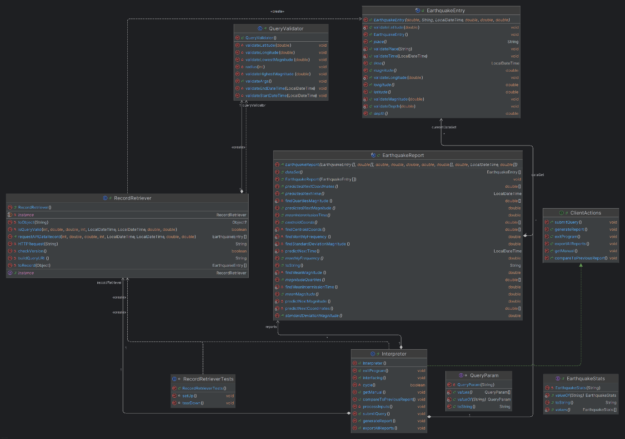
^ Obviously due to only using skeleton classes, relationships are not complete.

Libraries
To complete the UML, had to import the necessary dependencies.
Idk why, but there is so many variations of the date/time built-in libraries. Decided to use ‘java.time.LocalDateTime’ but that may change later.
David did mention to use an external library for JSONs. Asked some experienced classmates for which one is the best and they suggested “Gson” ( https://github.com/google/gson ). Seems to do at least the basics of “convert a JSON string to an equivalent Java object” so I installed it using Marven.
Also installed Junit for obvious reasons.

Implementing code
After realising the severe short time left, I decided to start implementing the code straight away.
There is no absolute limits for magnitude and depth so gotta research about that.
Used static methods and compact canonical constructor for the record component validation.
Earthquake entry record has been written up.
To make lambda streams easier to make and recognise, as well as demonstrating advanced understanding, will make them multiline with comments (instead of single-line).
Finding means are easy but quartiles are much more difficult to do so in a compact matter.
Compact code examples makes use of “[true or false statement] ? [code for true] : [code for false]”. This is a very useful way, and I think I remember that being demonstrated in one of the lectures. Will use it.
So apparently method references (like “EatthquakeEntry::latitude”) are not lambdas (like EatthquakeEntry -> EatthquakeEntry.latitude()). Apparently to the internet, method references are not lambdas and the assignment brief only shows lambdas for marks not method references. Does that mean using the better-practice method references, instead of lambdas, makes me lose marks?!
^ That realisation causes me to decide to focus more on stream use, than lambda, until I get an answer to this paradox!
Disabled “EarthquakeReport.predictNextMagnitude” and “EarthquakeReport.predictNextCoordinates” as their predicted values are, simply put, the means that are already calculated/processed. They may be reactivated if have time to code a better way to predict rather than just means. Prediction next time is not mean so will still use that.
Swapped ‘java.time.LocalDateTime’ with ‘java.time.ZonedDateTime’ to ensure that all date/times are in UTC time zone. Declaring the UTC time zone also makes me import ‘java.time.ZoneId’.
Similar story with magnitude standard deviation, will do at the end if have spare time.
Forgot to add/override toString method to the ‘EarthquakeEntry’. Just implemented that using ‘String.format’ to keep scope code clean (good practice).
Due to different measurements having differing accuracy, they are reflected by the number of decimal places permitted/rounded:
Measurement(s) | Precision
Latitude and longitude | 3 decimal places
magnitude | 1 decimal place
depth | 2 decimal places
time of earthquake | Seconds (integer)
Earthquake time prediction | Hours (1 d.p.)
Earthquake mean intermission time | Days (2 d.p.)

‘EarthquakeEntry.toString’ overridden.
Back to ‘EarthquakeReport’.
Seems canonical constructor demands the ‘.this(’ must be called first in this scope. This makes code inefficient as static methods that requires results in duplicate method calls. Search for a solution which seems to use a static factory method as explained in https://www.baeldung.com/java-constructors-vs-static-factory-methods . After reading I fully understand what it exactly is and how to use it as an alternative to the canonical constructor. The only part I am confused is the “of” syntax in the static factory method declaration – I know how to use it but not sure why its needed. Sources says the syntax is optional, but IDEA ide says otherwise. My guess is that it is another one of those good practices that IDEA ide enforces; this is so because this is not the first time IDEA ide forbids me certain codes that were proven to have nothing wrong with it.
Completely forgotten about depth. Since it’s a relatively simple measurement, and is not as important as the other statistics (such as magnitude), only the mean depth is needed.
New client action (interface method) added – view raw data set – in case user wants to see it again.
Second commit-and-push has been done
Consulted sources and determined that for geographic coords, it is ordered as latitude then longitude. Sources:
- https://www.movable-type.co.uk/scripts/latlong.html
- https://simonwrigley.medium.com/lat-lon-or-lon-lat-8adaf6441ccd
Confused why USGS permits negatives depths but https://www.usgs.gov/faqs/what-does-it-mean-earthquake-occurred-a-depth-0-km-how-can-earthquake-have-a-negative-depth explains that this is because of margin of errors. This page also says that 0km depth does not mean near non-existent earthquake (as I initially thought) but instead means unable to determine depth of an Earthquake instance. To reflect this in the assignment program, all earthquake entries, with a non-positive (including zero), are rejected to ensure local processing reliability.
For upper limit, depth is invalid if exceeding 800km (200 less than ASGS api acceptance) because the deepest recorded depth was ~735.8 km. Source - https://en.wikipedia.org/wiki/Deep-focus_earthquake .
Some utility methods are added to ‘QueryValidator’ to help with the validator methods.
Some method names, across the project, have been changed to make use of the “timestamp” terminology.
Realised query params need to be converted from string to validate, this makes a query param record the default choice as enum map can only hold one data type in the values (of the key-value pairs).
Added depth and limit validator methods to ‘QueryValidator’.
Will turn ‘QueryValidator’ into a record another time, it is 2:30 am and I am tired and nauseous.
Gonna write ‘HTTPRequest’ method by using David’s lecture example as a template. Seems to keep code organized, David made use of method overloading in the ‘Fetcher’ class.
Seems the sole purpose of “URI” is for stricter validation before making URL and easier to make using components instead of one single string arg. ‘HTTPRequest’ will assume that giving URL is already valid so URI will be used in another method.
URL seems to be a String wrapper class with extra methods specialised for HTTP communication from what I am seeing.
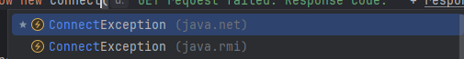
^ what? They even have the same parameter! Which one do I use?!

Academic week #10 (7th to 14th Dec)
So it seems u cant just convert json to any object, you either have to define the class that the json gets converted to or use a “JsonObject”. The later will be used.
Now that I think about it, JSON is not java core/vanilla code so how do I make streams compatible with JsonArray as it is an object instead of an array? … Turns out the answer was ‘StreamSupport.stream(‘ and ‘.spliterator()’.
Okay I think I made the first actually useful use of a lambda instead of a method reference:
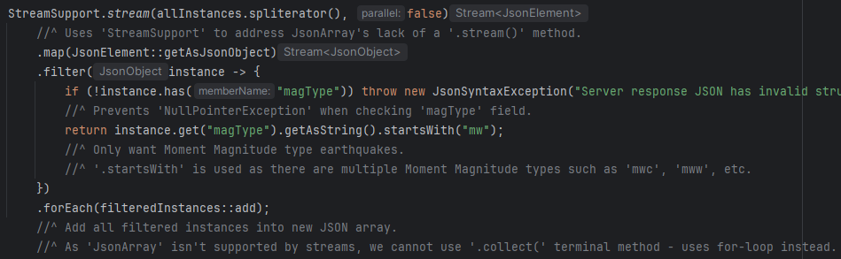
Do the unfamiliarity of the ‘com.google.gson’ library, ‘RecordRetriever’ has been altered – adding new methods, changing existing method declarations, etc.
Processing of JSON object has inflated the “RecordRetriever” class too much, will need to split it into “HTTPRetriever” and “JSONToRecord”.
Might be easier to use static classes instead of singletons but I never used static classes before so idk if it is right to use them. Internet sources only explains the differences between them as 1 instance vs 0 instance.
As mentioned previously, ‘QueryValidator’ class has been changed to ‘APIQuery’ record.
So apparently, unlike unchecked exceptions, checked exceptions require method signatures when their ‘throw’ code is used.
Despite ‘JsonObject’ having no problems in the code itself, it is not recognised, and thus gives error, when mentioned in the Java docs as “@param JsonObject”.
‘HTTPRetriever.HTTPRequest’ is too big, thus I decided to split it into ‘HTTPRetriever.sendToServer’ and ‘HTTPRetriever.fetchJSON’.
Didn’t do anything for a 3 days because I had to stop taking medication for a week, before taking a breath test, that and dieting before the test made me very unwell.
Will need dedicated method (JSONToRecord.‘unixToDateTime’) to convert unix epoch time to ‘ZonedDateTime’ as time is the only earthquake data needing conversion.
Surely ‘.getAsJsonPrimitive(’ includes Long, right? … never mind, I found ‘.getAsLong(’
Did another commit (3rd one).
I have validation methods for data values but not the for the data types themselves – validation user inputs. This will be covered in ‘Interpreter’.
Debating if ‘Interpreter.processInputs’ is worth existing but decided to keep it when realising that validating user-input timestamp will be a lot more complex than e.g. magnitude decimal value.
Thinking about how to user input a time stamp. Was thinking for user to input one time scale (days, minutes, etc) but that will overwhelm the user with inputs so on single input format will be used instead: YYYY-MM-DD:HH (UTC is assumed).
To validate this timestamp, without requires many steps and checks, regex will be used as I have used them before in other languages - experienced.
Now that timestamp validation has been done, will need to make a new ‘Interpreter’ method that converts that string to ‘ZoneDateTime’ format as its not as simple as parse method call.
Now that’s done, I should prob have a ‘Interpreter.viewManual’ method as the string will be too big to be in one single line. This will relate to the ‘ClientActions.getManual’ interface action. Makes ‘ClientActions.getManual’ more than just a forwarder method.
Actually… I don’t need ‘Interpreter.viewManual’, I will put the string in the interface manual action itself.
So it turns out that ‘.append’ (of ‘StringBuilder’) can chain upon itself.
Added starting timestamp and ending timestamp to the interpreter class as those are two query args needed by the report generation.
Did I mention I made a ‘InputType’ enumeration?
Made a ‘Command’ enumeration.
‘Interface.cycle()’ don’t actually need to return bool as the exit method will just exit the whole program itself.
So apparently if I have `public enum Command { QUERY }`, calling `Command.QUERY` won’t give an integer… Must be implemented differently in other languages. Whatever it is it will be too complex to fix, so ill just ignore enum in this enhanced switch statement.
In interpreter class, ‘exportAllReports()’ method will just export to console, and ‘compareToPreviousReport’ will be unimplemented, both to save development time (at least at the moment).
How on earth did I forget to make a static ‘Main.main(’?!
Alr, ill get to test run the code before continuing.
Fixes from test runs:
- Forgot to add new line character (‘\n’) in the ‘Interpreter.getManual()’ meth.
- ‘Interpreter.submitQuery’ output console instead of throwing exception when something goes wrong.
- Forgot to a try statement in ‘Instance.interfacing’ to print checked and unchecked errors thrown by other try statements from the called methods.
- Forgot to add input instructions for each individual instructions, could add a print statement to ‘Interpreter.processInput’ but I could add a print statement for the query args via lambdas instead (implemented in ‘Interpreter.)!
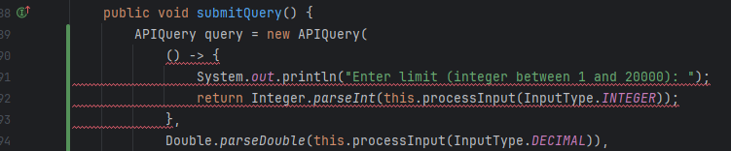
^ Well that didn’t work.
Ig ill just add string param instead of lambda.
- Replaced invalid inputs exceptions, in ‘Interpreter.processInputs’ with console outputs as user/client should be giving another chance to give valid input instead of cancelling the whole operation.
- Changed magnitude validation from ` (magnitude < -5.0 || magnitude > 10.0) ` to ` (magnitude > -5.0 && magnitude < 10.0) , also double checked the other mathematical validation statements.
- HTTP connection gets code 400. Investigated example generated URL:
“ https://earthquake.usgs.gov/fdsnws/event/1/query?format=geojson&jsonerror&limit=1&latitude=2.0&longitude=3.0&maxradiuskm=4&starttime2000-01-01T01:00:00Z&endtime=2010-01-01T01:00:00Z&minmagnitude=7.0&maxmagnitude=8.0&minDepth=9.0&maxDepth=10.0 ”
Seems the error JSON actually shows the reason for the rejection.
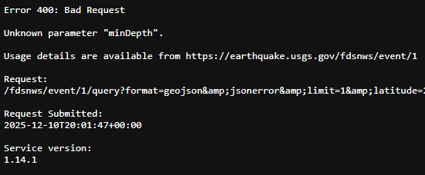
Forgot to add “=” to `START_TIME("starttime"),` and needed to get rid of some capitalisation.
- Some accidently inverted if-statements.
- Forgot that ‘api’ field is actually sub-field.
- Gson library treats Strings, in JSON, as primitives instead of objects – changed `.getAsJsonObject("place")` to `.getAsJsonPrimitive("place")`.
- ZonedTimeDate cannot be stored in JSON which means I cannot have ZonedTimeDate in the earthquake entry as otherwise ` gson.fromJson(formattedInstanceObj, EarthquakeEntry.class); ` will not work.
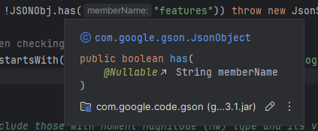
//^ Gson lib lacks java documentation – very inconvenient.

Commit notes
Fully implemented `EarthquakeEntry` record and implemented the essential parts of the `EarthquakeReport` record.
This made changes to the project skeleton plan:
* Declared `viewRawDataSet` action (in `ClientActions` interface) to prevent the earthquake report string representation from being too big for user to take in. This causes declaration of `EarthquakeReport.renderRawDataSet()` and `Interpreter.viewRawDataSet`.
* Declared and implemented `EarthquakeReport.findMeanDepth` and corresponding field.
* Swapped `java.time.LocalDateTime` with `java.time.ZonedDateTime`, throughout entire project, to enforce the UTC timezone. Additional imports are used in for further use of `ZonedDateTime`.
Next will need to do javadoc comments and further addition of earthquake depth integration.

Added initial project structure of Earthquake data handling, API fetching, records, enums, and validation classes. This is used to generate an initial UML.

Development log is kept in a MS Word doc for now. Manual will be in README.md in a letter commit.

Added Java docs to the records, made new records, added new classes and methods as the plan comes into the write-up.
Due to the use of images, development doc will remain as MS Word and now be included in the resp.
More information on changes can be seen in the development log file.
Written up “RecordRetriever” which was too large so splitted init “HTTPRetriever” and “JSONToRecord”.
Next will implement 'Interpreter'.

Questions asked to Copilot (using “Smart (GPT-5)”)
Question | Response
what do u call it when u generate cords for a point which is the avg point on the graph to all other points? | centroid
what do u call langtitude and langtitude together as one word? | coordinate
What import to use for ISO8601  and UTC format time and date | Too many to list, chose the ‘java.time.  LocalDateTime’ one
What types of magnitude scales are there? | https://www.usgs.gov/programs/earthquake-hazards/magnitude-types
What is the closest thing to a universal magnitude type/scale? | Mw (Moment Magnitude)
“fatal: mmap failed: Invalid argument” | Use “rm .git\index -Force” then “git reset”
Is “EatthquakeEntry::latitude” a lambda | That is a method reference which is not the same as a lambda.
Why are ‘ZonedDateTime’ instances not comparable? | They don’t implement the 'Comparable' interface.
Can an earthquake’s depth be negative? | https://www.usgs.gov/faqs/what-does-it-mean-earthquake-occurred-a-depth-0-km-how-can-earthquake-have-a-negative-depth
How do I use streams on unsupported data structures? | ‘java.util.stream.StreamSupport’

